Guideline – Insert Client Logo
Guideline –Template



Ryan wassell
BCDE311 – Software Development PROJECT
Semester 1, 2026
CITRENZ for Mehdi
Project Proposal
Version 0.3

Contents
Introduction 5
Project Details 6
Project Name 6
Overview of Industry Client 6
Project Background 6
Information Gathering 7
Documentation 7
Project Scope 8
Project Goal(s) 8
Benefits of Project 8
Project Requirements 8
Expected Deliverables 8
User Personas 8
Project Plan – High Level 9
Project Management Framework adopted 9
Phases 9
Timetable 9
Burndown Charts 9
Resources/Access Required 9
Risk Management 10
Approach 10
Risk Table 10
Quality Assurance 11
Approach 11
Quality Assurance Table 11
Test Plans – Functional and Usability 11
Project Management Framework Methodology 12
Overview 12
Literature Review 12
Critique (Pros and Cons) 12
Ethics 13
Relevance of ITP Code of Ethics 13
Relevant Legislation 14
Reflections 15
Approach 15
Specifications 16
Reference List 17
Appendices 18
Appendix A – Detailed Project Plan 18
Appendix B – Risk Management Table 18
Appendix C – Quality Assurance Table 18

Document Control
Date | Author | Version | Status of Document/Updates Made
23/02/2026 | Ryan Wassell | v0.1 | Document Creation, basic introduction added, placeholder title page
9/03/2026 | Ryan Wassell | v0.2 | Added Burndown Chart
17/03/2026 | Ryan Wassell | V0.3 | Added risk analysis, started project scope, started project plan – high level
22/03/2026 | Ryan Wassell | V0.4 | Added a couple personas; need to add more, added the notes from the meetings.
Dd/mm/yyyy | <Name of Student> | v1.0 | Signed Off, Submitted
Guideline – Effective Written Communication
Use these standards to create a document that is effective and well-written.
- Remove all guidelines from the document before submission.
- Cover Page – Ara Logo, Client Logo, Project Name, Client Name, Document Name, Student Name, Date, Version, Paper Code and Name, Pathway.
- Table of Contents (TOC) – No more than 3 heading levels, Table of Tables & Table of Figures not required.
- Document Control – keep this up to date.
- Header and Footer - Header contains Project Name, Client Name, Date ; Footer contains Student Name and Page Numbering (e.g. Page 1 of 10) ; Both Header and Footer in smaller font than body font size ; Header has a separating underline ; Footer has a separating overline.
- Use of Heading 1, 2, 3… for the TOC, Online navigation, and readability.
- Heading 1 Topics start on a new page.
- Diagrams, Charts, Tables have captions (if used).
- The document is optimised for black & white printing and colour-blind readers.
- APA v7 Reference List supported by in text referencing.
- The point of view of the document is consistent e.g., 1st person (I/we) or 2nd person (you) or 3rd person (he, she, it, they).
- Business/Professional Language used conveys a strong, clear and concise tone (active voice).
- Document is A4, double sided, font size is professional/business suitable, font size for body text is 10.5-to-12-point, single line spacing.
- Appendices included where useful to maintain flow of main document.
- Bullets used to help readability.
- Lead-In sentences/paragraphs to describe/introduce main sections (usually Heading 1 sections) and for diagrams/charts/tables.
- Do not split sentences/paragraphs over a page.
- If tables split over a page, use table headings.
- Use portrait and landscape page orientations to improve readability (Hint: this is done using section breaks).
- Include an introduction to the document after the Table of Contents - It will cover: the objective or purpose of the report (not the project); an outline of the report’s structure.
- Correct spelling & grammar for a business-English (NZ) audience.
- Wow-Factor - The overall design of the document is innovative/creative/positively memorable/relevant to the client/makes you want to read it.

Introduction
Guideline - the objective or purpose of the report (not the project) ; an outline of the report’s structure.
The purpose of this report is outline how I intend to carry out this project for the client. It will provide a clear explanation of the project’s details and scope; it will also provide the approach I will use to plan and deliver the product. This report will also detail the risks identified and some of the strategies used to mitigate them, the quality assurance I intend to follow during development, and the project management framework I will use throughout the project lifestyle.

Project Details
Guideline - lead in sentence to describe this section
This section is to present the details of this project.

Project Name
Guideline - Short, Sharp, Catchy
Citrenz Conference Website

Overview of Industry Client
Guideline - Who is the client?

Project Background

Overview
Guideline – Why is the project important to the client? What is the business problem/opportunity?
There is currently no conference website for CITRENZ as the old one dissolved. The opportunity we were given is to fill that gap with a new conference system website.

Current Situation
Guideline – what is happening today for the client – before the project is started?

Future Situation
Guideline – what does the situation look like for the client once the project is completed?

Information Gathering
Guideline - lead in sentence to describe this section
This section will show the information that has been gathered by the client.

Documentation
Guideline: document the questions and answers and summary analysis you made from your interview with the client.
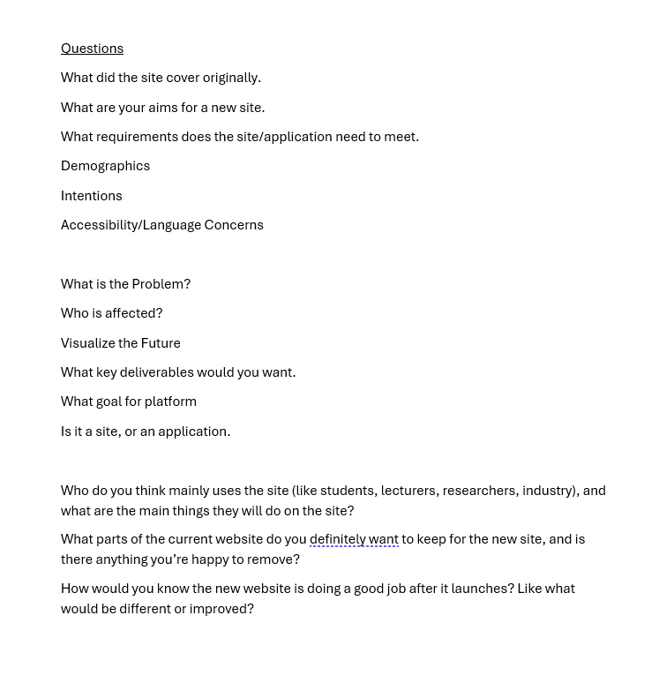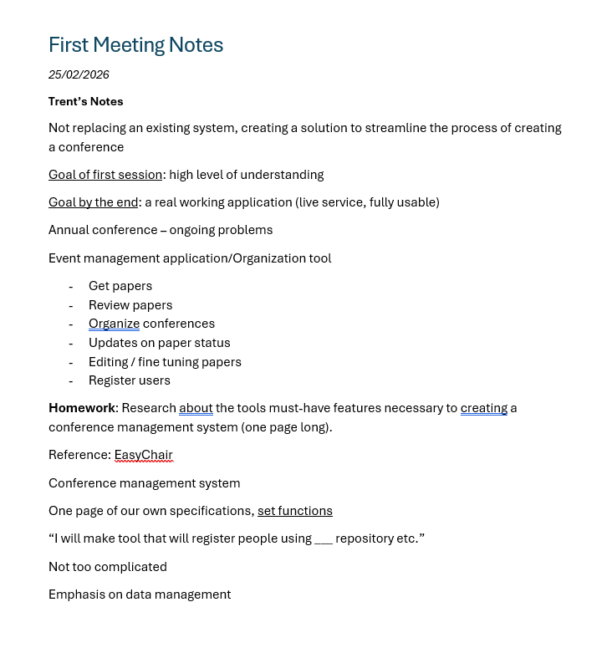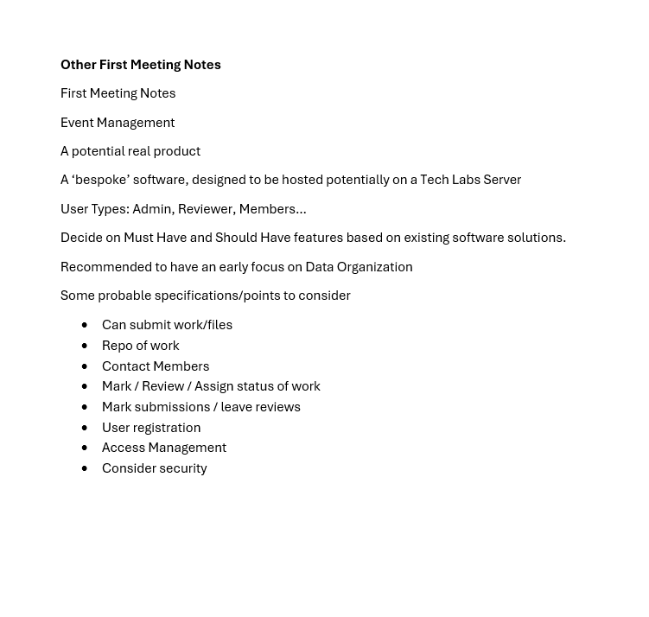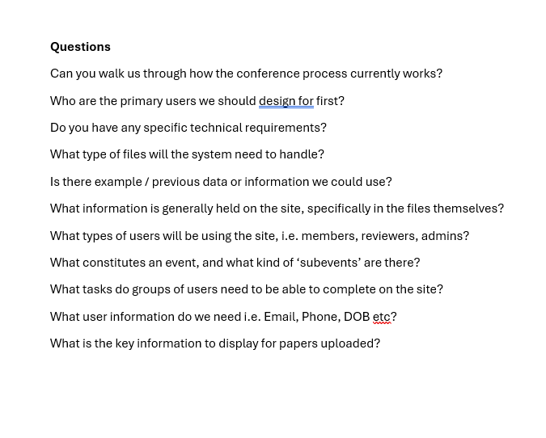
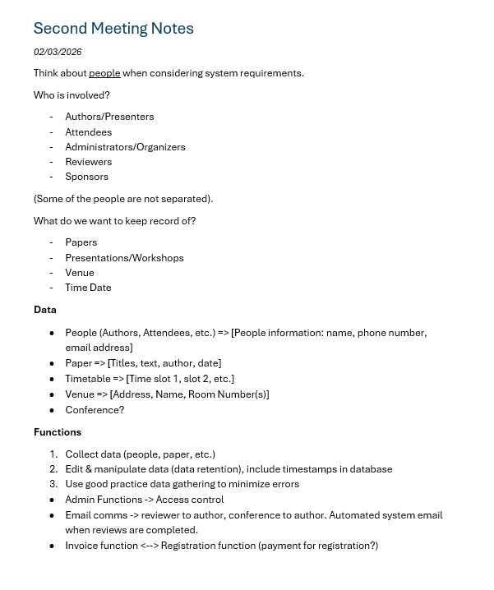

Project Scope
Guideline - lead in sentence to describe this section
This section will outline the goals, requirements and deliverables of the project.

Project Goal(s)
Guideline – what specific goals/outcomes will the project achieve for the client
The goal for the client is to have a space which will streamline the process of creating a conference for Citrenz.

Benefits of Project

ID | Description | Priority
FR1 | User must be able to make an account | MUST
FR2 | User must be able to log in to the system | MUST
FR3 | Administrators/Organizers must be able to create a conference | MUST
FR4 | Users must be able to upload files for review | MUST
FR5 | Authors must be able to track submission status | MUST
FR6 | Reviewers must be able to review papers | MUST
FR7 | Users must be able to book a seat for the conference | MUST
FR8 | Users must be able to see conference details such as date/time, venue, speakers etc | MUST
FR9 | System should notify users when reviews are completed | SHOULD
FR10 | System should store timestamps when data is created or manipulated | SHOULD
FR11 | System may support invoicing for registration | COULD
FR12 | System may show sponsor information | COULD

Project Requirements

Expected Deliverables
Guidelines – make a list of the deliverables
A functional website with the required features

User Personas
Guidelines – describe the target personas
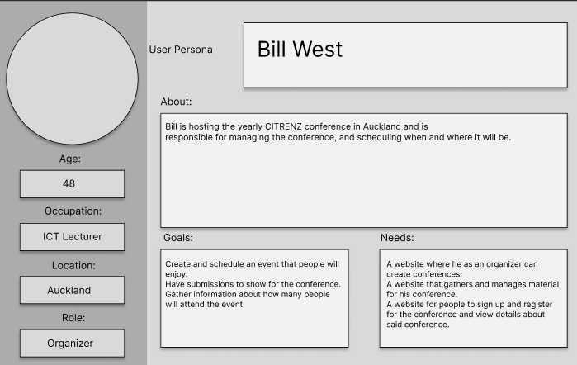
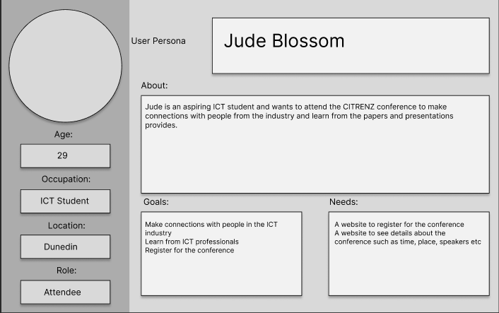
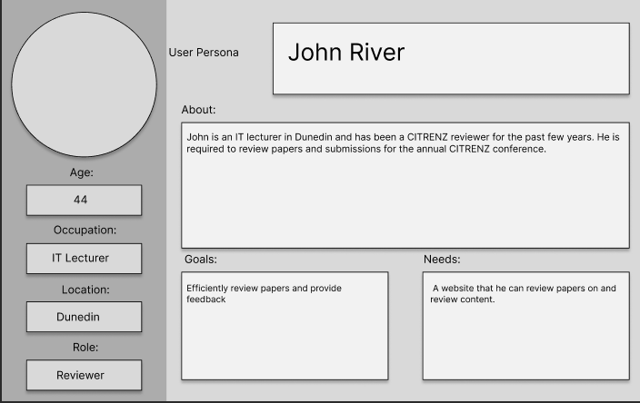

Project Plan – High Level
Guideline - lead in sentence to describe this section

Project Management Framework adopted
Guideline – an overview of the Framework adopted
The kanban framework allows me to visualise the work needed to be done through a table with 3 Headers:
- To Do – These are the ultimate tasks that need to be completed but not have started yet
- Doing – These are the tasks that you are currently doing
- Done – These are the tasks that you have completed
I enjoy this framework due to its simplicity and flexibility. I am using Trello as it is easily customisable. An example of a Kanban board I have made on Trello:
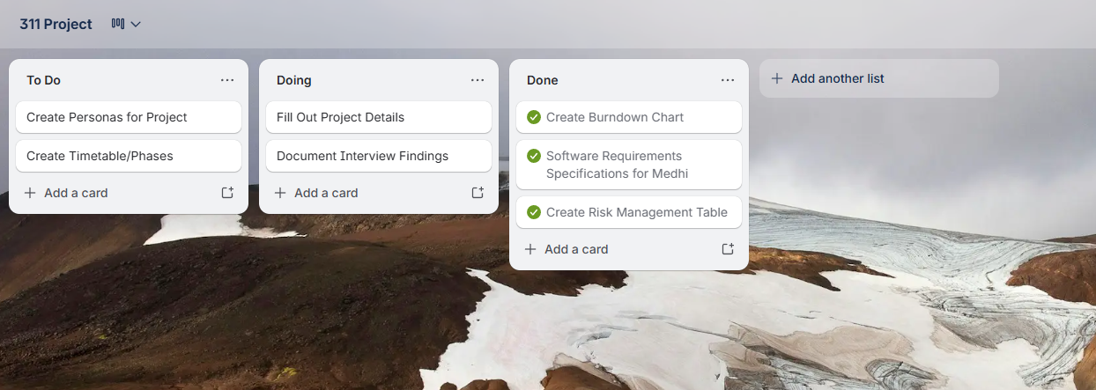

Phases
Guideline – the major phases of the project, include the estimated task breakdown

Timetable
Guideline – includes the order of the tasks within the phases, the forecasted hours per task and phase, due dates for deliverables, (the timeline will be updated with actual hours and delivery dates as the project progresses).
Burndown Charts
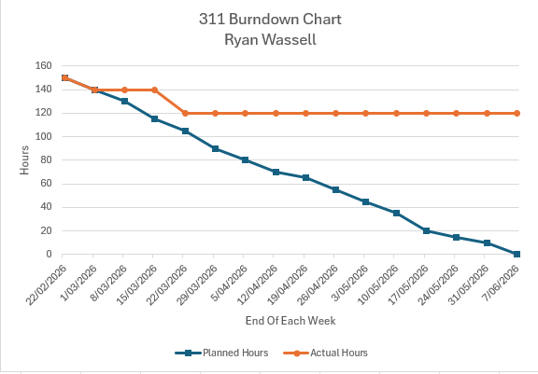

Resources/Access Required

Risk Management
Guideline - lead in sentence to describe this section
This section will outline the risk analysis too I used and the risks I have analysed.

Approach
Guideline – describe the selected approach/framework/method for risk identification and management, why it was selected, how often the risks will be reviewed, and how to read the risk table.
I am using the simple Microsoft risk table template with adjustments to allow post mitigation risk analysis. I selected this one because I am familiar with it. The risks will be reviewed every time a new phase occurs. For each item in the risk table there will be a pre mitigation risk assessment and post mitigation risk assessment, which can be understood by looking at the exposure (out of 10) to see the analysis of how risky a certain statement is.

Risk Table
Guideline – no more than top 5 risks, covering business, project, personal etc – identify the Probability, Impact and rank by exposure, Create Mitigation, Contingency and Triggers – this plan will be updated throughout the project. The full table and updates may be placed in an appendix for readability.
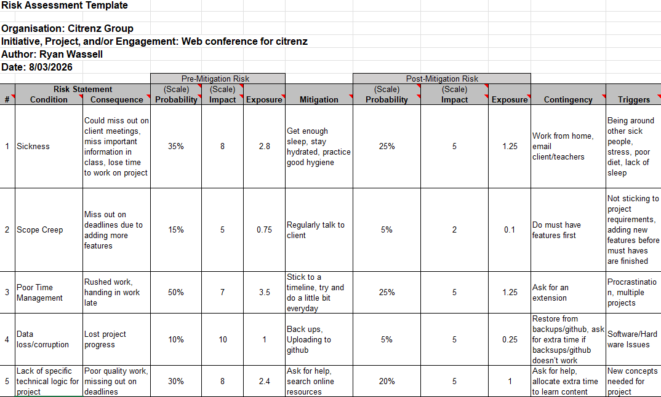

Quality Assurance
Guideline - lead in sentence to describe this section

Approach
Guideline – describe the selected approach/framework/method for maintaining quality assurance (deliverables must meet client and good practice criteria) ,why it was selected, how often the quality assurance table will be reviewed, and how to read the quality assurance table.

Quality Assurance Table
Guideline – this is a list of all deliverables, the criteria for acceptance, who will accept them and date of acceptance.

Test Plans – Functional and Usability
Guideline – detail your separate Functional and Usability testing plans – you will use these, update and document the results during the project.

Project Management Framework Methodology
Guideline - lead in sentence to describe this section

Overview

Literature Review

Critique (Pros and Cons)

Ethics
Guideline - lead in sentence to describe this section

Relevance of ITP Code of Ethics
Guideline – see https://itp.nz/s/ITP-Code-of-Ethics.pdf for further information

Good Faith
Guideline – the student shall treat people with dignity, good faith and equality; without discrimination; and have consideration for the values and cultural sensitivities of all groups within the community affected by their work;

Integrity
Guideline – the student shall act in the execution of their profession with integrity, dignity and honour to merit the trust of the community and the profession, and apply honesty, skill, judgement and initiative to contribute positively to the well-being of society;

Community Focus
Guideline - Responsibility for the welfare and rights of the community shall come before their responsibility to their profession, sectional or private interests or to other professionals;

Skills
Guidelines – students shall apply their skills and knowledge in the interests of their clients or employers for whom they will act without compromising any other of these Tenets;

Continuous Development
Guideline - students shall develop their knowledge, skills and expertise continuously through their careers, contribute to the collective wisdom of the profession, and actively encourage their associates to do likewise;

Informed Consent
Guideline - students shall take reasonable steps to inform themselves, their clients or employers of the economic, social, environmental or legal consequences which may arise from their actions;

Conflicts of Interest
Guideline - students shall inform their clients or employers of any interest which may be, or may be perceived as being, in conflict with the interests of their clients or employers, or which may affect the quality of service or impartial judgement;

Competence
Guideline – students shall follow recognised professional practice, and provide services and advice carefully and diligently only within their areas of competence.

Relevant Legislation
Guideline – see https://www.privacy.org.nz/ and https://www.iponz.govt.nz/

Privacy/Confidentiality
Guideline: what aspects of privacy/confidentiality practice/legislation are relevant to the project.

Copyright
Guideline: what aspects of copyright practice/legislation are relevant to the project.

Patents
Guideline: what aspects of patents practice/legislation are relevant to the project.

Reflections
Guideline - lead in sentence to describe this section

Approach
Guideline: what is the way that notes will be taken to capture lessons learnt and reflections during the project.

Specifications
Guideline - this is a placeholder to indicate you will be creating specification documentation derived from your initial low-fidelity wireframe / story board processes and submitting them in an appropriate manner here.

References
Guideline – APA v7, supported by in-text references.

Appendices
Guideline - lead in sentence to describe this section

Appendix A – Detailed Project Plan
Guideline – work breakdown structure including phases, tasks, deliverables, time allocated, completion dates, resources.

Appendix B – Risk Management Tables
Guideline -Use this to give provide updates of the risk tables and other evidence that may not be suitable to display in the main report section – example of a table from WIL Capstone Project Risk Management
Table B4
Risk Issues Management - 3 October 2022
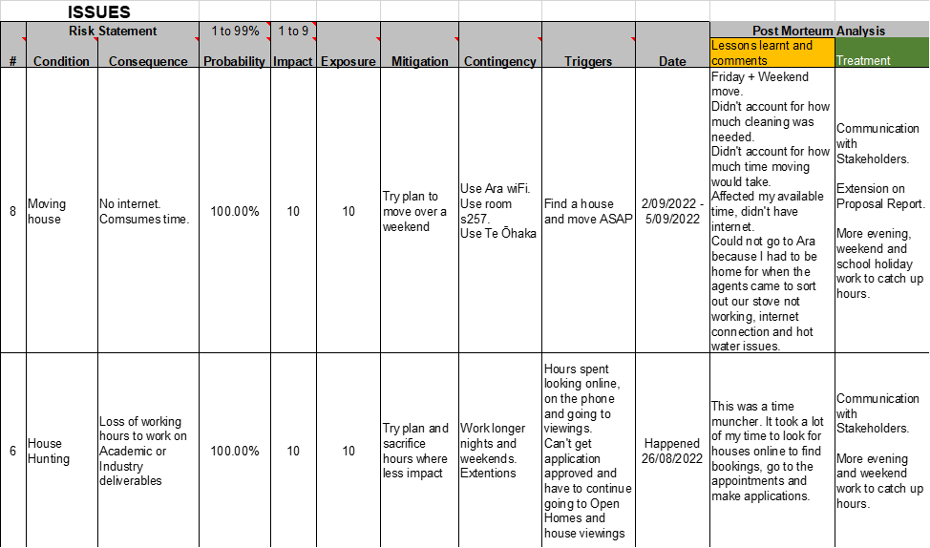
Version 1 of Risk Assessment – 8/03/2026


Appendix C – Quality Assurance Tables
Guideline -Use this to give provide updates of the QA table and other evidence that may not be suitable to display in the main report section

